Rossmoyne Senior High School

ATAR course examination, 2020

Question/Answer booklet

Physics
Unit 3 & 4

Student number: In figures
In words ________________________________________

________________________________________

Time allowed for this paper
Reading time before commencing work: ten minutes
Working time: three hours

Materials required/recommended for this paper
Number of additional
answer booklets used
(if applicable)

To be provided by the supervisor:

- This Question/Answer Booklet; Formula and Constants sheet

To be provided by the candidate:
- Standard items: pens, pencils, eraser or correction fluid, ruler, highlighter.

- Special items: Calculators satisfying the conditions set by the SCSA for this subject.

Important note to candidates
No other items may be taken into the examination room. It is your responsibility to ensure that you do not have any unauthorised material. If you have any unauthorised material with you, hand it to the supervisor before reading any further.

Structure of this paper

Section | Number of questions available | Number of questions to be answered | Suggested working time  (minutes) | Marks available | Percentage of exam
Section One:  Short answer | 13 | 13 | 50 | 54 | 30
Section Two:  Extended answer | 7 | 7 | 90 | 90 | 50
Section Three:  Comprehension  and data analysis | 2 | 2 | 40 | 36 | 20
 |  |  | Total | 180 | 100

Instructions to candidates

- The rules for the conduct of Western Australian external examinations are detailed in the Year 12 Information Handbook 2019. Sitting this examination implies that you agree to abide by these rules.

- Write your answers in this Question/Answer Booklet.

- When calculating numerical answers, show your working or reasoning clearly. Give final answers to three significant figures and include appropriate units where applicable.

When estimating numerical answers, show your working or reasoning clearly. Give final answers to a maximum of two significant figures and include appropriate units where applicable.

- You must be careful to confine your responses to the specific questions asked and follow any instructions that are specific to a particular question.

- Spare pages are included at the end of this booklet. They can be used for planning your responses and/or as additional space if required to continue an answer.
  - Planning: If you use the spare pages for planning, indicate this clearly.
  - Continuing an answer: If you need to use the space to continue an answer, indicate in the original answer space where the answer is continued, i.e. give the page number. Refer to the question(s) where you are continuing your work.

Section One: Short response 30% (54 Marks)

This section has thirteen (13) questions. Answer all questions. Write your answers in the space
provided. Suggested working time for this section is 50 minutes.

Question 1 (4 marks)
Complete the table below concerning the forces within an atom as explained by the Standard Model.
Force within atom | Fundamental Force | Force-Carrying Gauge Boson
The repulsion of protons within a nucleus
The attraction of quarks in a nucleon

Question 2 (4 marks)
Find the net force acting on the 3.00 µC in the diagram below. Include a direction.

-
-
+
3.00 µC
-4.00 µC
-5.00 µC

2.50 cm
2.00 cm

Net force: ___________________________

Question 3 (4 marks)
In relation to Young’s double slit experiment, state whether the following statements are true or false.
Statement | True or False
The results of the double slit experiment using a beam of light supports evidence that light travels in discrete packets of energy, called photons.

The results of the double slit experiment using a beam of electrons supports evidence that matter behaves as a wave.

An electron beam directed at the slits must have a high enough density of electrons to cause an interference pattern.
Using a detector at one or more of the slits to confirm the presence of any electrons will remove the interference pattern.

Question 4 (5 marks)
Explain how the detection of muons created in the upper atmosphere at ground level provides supporting evidence of time dilation as predicted by Einstein’s special theory of relativity.

Question 5 (4 marks)
Arrange the following list of matter in order of formation in the universe according to the Big Bang Theory.
- Baryons, Nuclei, Light elements, Stars, Quarks and leptons, Heavy elements

- _______________________ (formed first)
- _______________________
- _______________________
- _______________________
- _______________________
- _______________________ (formed last)

Question 6 (4 marks)
A cyclist on a banked curve is moving at a steady speed and following a horizontal circular path with a 12.0 m radius. The banked curve has an incline of 14.0°. Calculate the speed of the cyclist such that no frictional force is required to maintain the circular motion. Use a vector diagram to support your answer.

Velocity: ________________________m s⁻¹
Question 7 (5 marks)
A plane’s wingtips can generate an EMF as the plane cuts flux lines of Earth’s magnetic field. The diagram below shows the top down perspective of the plane flying at 140 km h⁻¹ towards the top of the page while the component of Earth’s magnetic field directed out of the page is 45.0 µT. This generates a 7.88 mV potential across the plane’s wingtips.

- Label, on the diagram of the plane, the polarity of the induced emf in the wings. (1 mark)

- Calculate the length of the wings, from one tip to the other. (4 marks)

Length: ________________________m

Question 8 (4 marks)
The curve below shows the expectated spectrum of a black body using classical physics.

Relative intensity

Wavelength

On the same set of axis, draw two (2) new curves representing a black body spectrum using a quantum model of light – one at 1000 K and one at 5000 K. Label each curve.
Question 9 (4 marks)
Consider a proton accelerated to a speed of 2.89 × 10⁸ m s⁻¹. Calculate the magnitude of its kinetic energy.

Kinetic energy: ________________________J

Question 10 (3 marks)
The Michelson-Morley experiment was designed to determine the speed of the luminiferous aether; a proposed medium permeating space that was thought to be the carrier of light waves. State the result of this experiment and comment on its effect on Einstein’s theory of special relativity.

Question 11 (4 marks)
A projectile is fired with a muzzle velocity of 115 m s⁻¹ at an angle of elevation of 25.0° above the horizontal, towards a vertical cliff face 6.00 x10² m away as shown in the diagram.

600 m

Ignoring air resistance, calculate the vertical height that it strikes the cliff.

Vertical Height: ________________________m

Question 12 (5 marks)
A 8.00 cm long magnet is allowed to fall under the influence of gravity through a single loop of wire with an area of 0.0590 m² and connected to a resistor (at the front of the ring) to provide an electrical load.

(a) On the diagram, draw the induced magnetic field and show the direction of induced current in the coil.
a
S
Resistor
N
(2 marks)

(b) Given the magnetic field within the coil changes from +52.3 mT to -10.5 mT in a time of 0.120 s, calculate the average induced emf in the coil in this period. (3 marks)

Average Induced emf: ________________________V

Question 13 (4 marks)
A simplified diagram of a DC motor’s coil within a magnetic field is shown below.
A
S
N

B

- State the direction of the current required in wire A such that the force felt by wire A is directed down the page. (1 mark)

- The motor uses a split ring commutator. Explain the function of this component. (3 marks)

End of Section One

This page has been left blank intentionally

Section Two: Problem-solving 50% (90 Marks)

This section has seven (7) questions. You must answer all questions. Write your answers in the
space provided. Suggested working time for this section is 90 minutes.

Question 14 (14 marks)

Jill is based on Earth while Henry flies past in a spaceship at 0.750 c. Henry has a particle accelerator, capable of firing electrons at 0.600 c as measured from the frame of the particle accelerator. He uses the particle accelerator to fire an electron from the front of his spaceship to the back, which he observes take 5.60 × 10⁻⁸ s.

- Calculate the velocity of the electron as observed by Jill. Include a direction. (4 marks)

Velocity: ________________________m s⁻¹ Direction: _________________________

- Calculate the length of the spacecraft as measured by Jill on Earth. (3 marks)

Length: ________________________m

- Which observer, Henry or Jill, will observe the largest dilation of time for the electron frame. No calculation is required, but you must justify your choice referring to principles of special relativity. (3 marks)

- Knowing that the proper time it takes for the electron to reach the back of the spacecraft is observed from the rest frame of the electron, calculate the time Jill observes for the electron to reach the back of the spacecraft. (4 marks)

Time: ________________________s
Question 15 (14 marks)

A remote community uses a generator to provide electricity for its residents. The 195 kW generator has an output voltage of 855 V on the town outskirts, being connected with transmission lines with total resistance of 7.43 Ω. The electricity is stepped up from the generator, with 300 turns on the primary coil and 3400 turns on the secondary. The voltage is then stepped back down to 240 V by a second transformer in the centre of the town.

(a) Calculate the secondary voltage of the first transformer. (2 marks)

(b) Assuming the transformer is 100% efficient, calculate the current that flows through the transmission lines. (2 marks)

(c) Calculate the power loss along the transmission lines and the total voltage drop along the transmission lines. (4 marks)

(d) The iron core within a transformer is made of thin laminated strips. Explain why a laminated iron core is used instead of a solid iron core in transformers. (3 marks)

The residents notice that the voltage supplied during the middle of the day (when the demand on
the electrical grid is at its highest) drops to 237 V and during the early morning, it rises to 241 V.
This is while the generator is operating at its desired output voltage of 855 V.

(e) Explain the cause of this observation. (3 marks)

Question 16 (10 marks)

A particle consisting of four quarks and one anti-quark is called a pentaquark. Pentaquarks were theorised as early as 1964 and the first evidence of their existence obtained in 2003. However, it wasn’t until 2015 (and again in 2019) that enough data had been gathered to make a genuine claim that a particle had been discovered that matched the theoretical properties of a pentaquark.

- Show, via a calculation, that a pentaquark has a baryon number of +1. (2 marks)

- The equation below describes the formation of a pentaquark. A lambda baryon, $Λ_{b}^{0}$ ($bud$) decays via a $W^{-}$ boson, forming a kaon minus, $K^{-}$ ($s\overline{u}$) and the pentaquark, $P_{c}^{+}$ ($u\overline{c}cud$).

$$Λ_{b}^{0}→ K^{-}+P_{c}^{+}$$

  - State which fundamental force is responsible for mediating this decay. Justify your choice. (2 marks)

Force: _______________________

Justification:

  - Mesons are a composite particle consisting of a quark and an antiquark. State the names of the fundamental particles of the meson in the decay reaction.
(2 marks)

  - Show that electric charge is conserved during this decay. (2 marks)

  - Show that baryon number is conserved during this decay. (2 marks)

Question 17 (14 marks)

A conductor carrying a current of 10.0 A to the right is placed in a uniform 2.00 N C⁻¹ electric field acting upwards (as shown in the diagram). Electrons enter the electric field at different distances from the conductor and travel parallel to the conductor at a speed of 8560 m s⁻¹. A magnetic field is produced in the same region as the electric field by the current-carrying conductor. The electron at a perpendicular distance $r_{0}$ from the conductor (see the diagram) maintains a constant velocity while it is travelling through the two fields.

While completing this question, the effect that the charge on each electron has on other electrons can be ignored.

Electric Field
2.00 N C⁻¹

Electrons
8560 m s⁻¹

$$r_{0}$$

Conductor
10.0 A

- State the direction of the magnetic field above the conductor. (1 mark)

- Calculate the force on the electrons caused by the electric field. Include a direction.
(3 marks)

Force: ________________________N Direction: _______________________

- The path followed by the electron at a distance $r_{0}$ from the conductor is shown as a dashed line. For the remaining two electrons in the diagram (above and below the electron at $r_{0}$), sketch the paths they would take as they entered the region occupied by both the electric field and the magnetic field. (2 marks)

- Explain your choice for the electron path drawn in part (c) for the electron closest to the conductor.
(4 marks)

- Calculate the distance $r_{0}$. (4 marks)

$r_{0}$: ________________________ m

Question 18 (13 marks)

A man is moving a 35.0 kg bookshelf and is startled by a very large cat with a mass of 16.0 kg. The bookshelf becomes unbalanced and the man supports it as shown in the diagram below. The cat jumps on to the bottom end of the bookshelf and begins walking towards the top of it. The man always applies a force at right angles to the bookshelf to prevent it falling on to him.



50⁰

- The bookshelf is 2.40 m tall with a uniformly distributed mass. The man is pushing with a maximum force of 270 N at a distance of 0.600 m from the top end of the bookshelf. Calculate how far up from the bottom end of the bookshelf the cat can walk before the man is unable to support it. (4 marks)

Distance: ________________________ m

- Calculate the magnitude of the reaction force the carpet applies to the bookshelf when the man must push with his full strength. (4 marks)

Force : ________________________ N

- Describe how the direction of the reaction force the carpet applies to the bookshelf changes as the cat walks up the bookshelf. Explain your reasoning (no calculations required).
(5 marks)

Question 19 (14 marks)

A photoelectric effect experiment using copper as the target anode is shown in the diagram below.

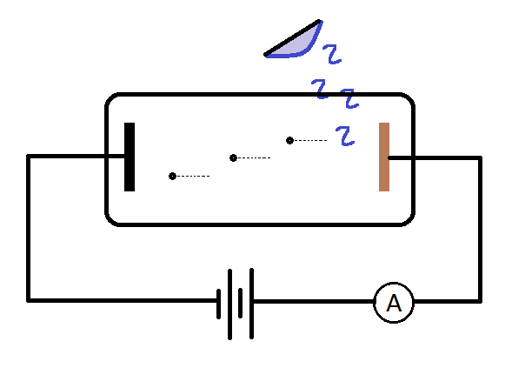
The required stopping voltage (V) to reduce the current reading in the ammeter to zero for a variety of light frequencies was recorded.

Frequency (×10¹⁵ Hz) | Stopping voltage (V) | Max Kinetic Energy of Photoelectrons (×10⁻¹⁹ J)
1.0 ± 0.2 | - | -
1.5 ± 0.2 | 1.10 | 1.76
1.9 ± 0.2 | 2.76 | 4.42
2.3 ± 0.2 | 4.42 | 7.07
2.9 ± 0.2 | 6.90

- The lowest incident frequency used did not have a stopping potential measurement. Suggest a reason why. (2 marks)

- Calculate the maximum kinetic energy of the photoelectrons produced from a 2.90 × 10¹⁵ Hz light source. Add this value to the table of results. (2 marks)

- Draw a graph maximum kinetic energy ($E_{k}$) of the photoelectrons (in joules) vs frequency ($f$). Place $E_{k}$ on the vertical axis for which the scale is already provided. Add error bars for the frequency values. Include a line of best fit. (5 marks)

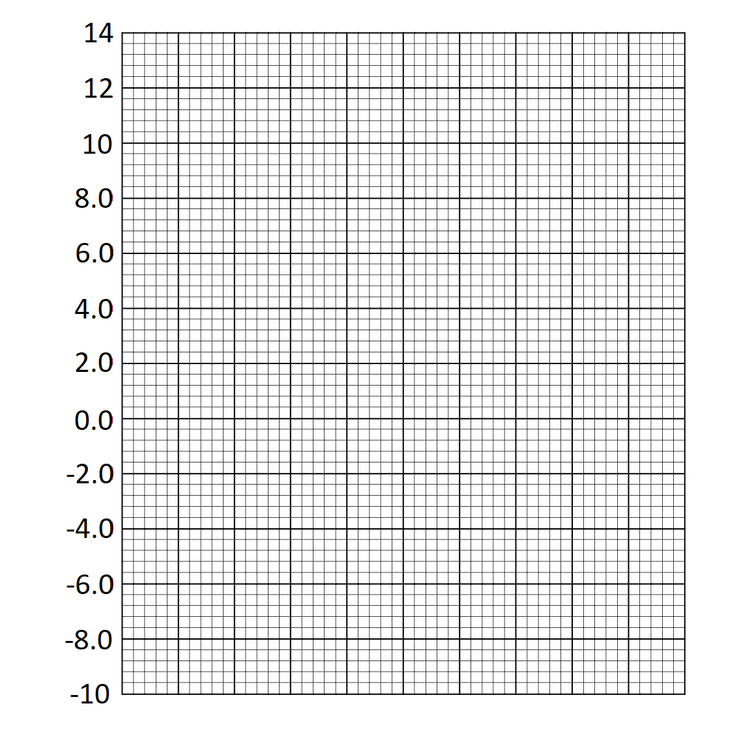
$E_{k}$
(× 10⁻¹⁹ J)

- Using the graph, determine the work function ($W$) of copper. Justify your answer.
(2 marks)

Work Function: _______________________

Justification:

- Calculate the gradient of the graph and use this value to determine Planck’s constant.
(3 marks)

Planck’s constant : ________________________ J s

Question 20 (11 marks)

The graph below is representative of the findings of Edwin Hubble, who researched cosmological concepts that led to the Big Bang Theory.

- Describe the relationship that is observed within this graph. (2 marks)

- The Steady State Theory preceded the Big Bang Theory. The Steady State Theory lost acceptance in the scientific community based on the work of Hubble. Explain how the relationship shown in the graph supports the Big Bang Theory and is in contradiction to the Steady State Theory. (3 marks)

- Hubble’s law is described by the following equation:

$$v=H_{0}D$$

Where $v$ is the recessional velocity of a galaxy and $D$ the distance of a galaxy.

  - Use the graph to calculate a value for Hubble’s constant ($H_{0}$), which has units km s⁻¹ Mpc⁻¹. You must add construction lines to the graph to show how your answer was obtained. (3 marks)

$H_{0}$: ________________________ km s⁻¹ Mpc⁻¹

  - At sufficiently large distances ($D$), the velocity of a galaxy ($v$) would be predicted to be larger than the speed of light. Comment on whether or not Hubble’s Law can be applied at these large distances. (3 marks)

End of Section 2

This page has been left blank intentionally
Section Three: Comprehension 20% (36 Marks)

This section contains two (2) questions. You must answer both questions. Write your answers in
the spaces provided. Suggested working time for this section is 40 minutes.

Question 21 (18 marks)

The Mass Spectrometer
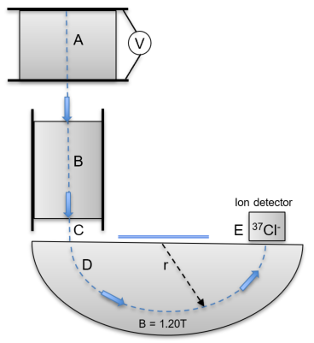
A beam of gaseous ions can be separated into components with different values of charge divided by mass (known as the q:m ratio). The ion beams are detected with an electrometer in an instrument called a mass spectrometer. The diagram below shows a mass spectrometer. Ions are accelerated from rest by an electric field (A) and enter a region called a velocity filter (B) which removes any ion without a set velocity. This enables a stream of negative ions of chlorine isotopes to emerge from the slit (C) with a speed of 2.50 x 10⁵ m s⁻¹. They are then deflected (D) by a magnetic field of uniform flux density 1.20 T. The velocity filter (B) ensures that all ions emerge into the magnetic field with the same speed. The masses of the two main isotopes of chlorine are shown below.

m ³⁵Cl⁻ = 5.81 x 10⁻²⁶ kg
m ³⁷Cl⁻ = 6.14 x 10⁻²⁶ kg.

(a) Calculate the maximum voltage at region A required to accelerate the ions to the speed stated. (3 marks)

Question 21 (continued)

(b) Explain why the ions move in a semi-circular path through the magnetic field (D). (3 marks)

(c) State the direction the magnetic field must be to produce curved path (D) as shown in the diagram. (1 mark)

(d) Calculate the radius of curvature of the ³⁵Cl⁻ ions through the magnetic field. (3 marks)

Question 21 (continued)

The “Particle motion in a magnetic field” equation is provided in your Formulae and Data Booklet.

(e) Rearrange this equation to express the charge: mass ratio and calculate the charge: mass ratio for ³⁵Cl⁻ ions. Use a radius of 0.0850m if you could not determine an answer to part (d). (3 marks)

Question 21 (continued)

(f) Calculate the ratio of the radius of curvature of the ³⁷Cl⁻ ions compared to the ³⁵Cl⁻ ions.
(2 marks)

Accelerators, where particles are accelerated to high speeds, will often require relativistic effects to be considered.

(g) Show, via an appropriate equation, that relativistic effects do not need to be considered for this particular analysis. (3 marks)

Question 22 (18 marks)

Geosynchronous Orbit

Satellite orbits around Earth are classified according to altitude. At one extreme is the low Earth orbit (LEO) which skims the upper atmosphere. The International Space Station orbits here, a measly 410 km above the Earth’s surface. This is so close to Earth that without constant corrections, the thin amount of atmosphere at this height would drag the station 2 km towards Earth in a month. Satellites in this orbit have very short viewing windows from a single location on the Earth but will often return to the same portion of sky quickly, particularly if the orbit is very equatorial. The advantage of this orbit is that electronic equipment is protected from harsh solar winds which are high speed charged particles ejected from the Sun.

At the other extreme of satellite orbits is the high Earth orbit (HEO). Out in HEO there is no protection against solar winds. The HEO sits above the medium Earth orbit (MEO). The boundary between the two occurs at the geosynchronous orbit (GSO). The GSO is the exact altitude at which a satellite’s orbital period matches the rotation of the Earth about its axis; these satellites take 24 hours to complete an orbit. Because GSO satellites take the exact same time to orbit as the Earth takes to rotate, it is possible they may maintain their position above the same patch of ground – they are in sync with the Earth. This is shown in the diagram below. After half an orbital period, the same land mass is below the satellite.

GSO are great to ensure that communication with the satellite is never interrupted. A ground station cannot communicate with a satellite that is in space above the far side of the planet – just as mobile phone reception does not work in an underground car park – too much solid matter blocks the signal. GSO is quite an altitude to reach though, as it is an order of magnitude higher than LEO, thus it takes significantly more energy (fuel) to reach this orbit. That said, it such a useful orbit that over 400 satellites currently reside here. When these satellites are decommissioned they are sent to a graveyard orbit that is even higher in HEO so as to keep the GSO clear for future use.

- Suggest why satellites are protected from solar winds in LEO. (1 mark)

- Explain why the International Space Station uses frequent thruster boosts. (5 marks)

- Show, using suitable calculations, that the International Space Station would not be visible from a single location on Earth for very long. (4 marks)

- Australia wants to launch a satellite that can monitor cloud coverage of the Australian continent. Suggest an orbit to place the satellite in and justify your choice.
(2 marks)

- State two (2) disadvantages of a HEO. (2 marks)

- Calculate the altitude of the boundary between MEO and HEO. (4 marks)

Altitude: ________________________ m

End of Questions

This page has been left blank intentionally

Additional working space

Spare grid for graph


End of examination
Acknowledgements

Question 16
Feynmann diagram of pentaquark creation
CERN on behalf of the LHCb collaboration
https://commons.wikimedia.org/wiki/File:Pentaquark-Feynman.svg
CC BY 4.0

Question 17
Cat Drawing by Unknown Author is licensed under CC BY-NC-ND

